The general trend here is that music streaming apps have a general net loss when it comes to revenue, however that does not mean that the apps are unsuccessful or that they are losing money (although technically they are). This is something that we should be aware of, and expect (at least to begin with).

Spotify, being the biggest streaming service currently, makes over $3bn each fiscal year, although had a net loss of $220m. Spotify must pay very high royalties due to the ‘access on demand’ side of the service, but still has a high number of free users, which is something that we should avoid if we want the system to be financially viable. 52% of all traffic comes from Mobile devices, so this is the market we should focus on initially.

On the other hand, Shazam is one of a select few music services that has a positive net revenue or is very close to one. Shazam’s business model is interesting in that it takes advantage of its limitations to make more money. To avoid having to pay a lot of royalties, music is limited to short clips (20-30s long), and instead Shazam makes its money through advertisement and through the referral of the user to other streaming services.

The other ‘similar’ music streaming services worth noting are the American ‘Pandora’ service, which in 2016 had a gross revenue of $1.39bn and net loss of $343m (with $1bn made in ads), and Soundcloud, which is valued at around $800m but has a net loss of $20-30m every year.

As our system will have to pay royalties for playing music, I believe that the only way that it could be financially viable is by implementing Ads alongside a subscription-based model like we discussed, where a free user will have limited functionality of the system (in the form of limited votes), and a premium user will be able to cast votes as often as they like.

Another feature that would increase the likely success of the app is similar to what Shazam does, in terms of referral to other music streaming/purchasing systems. Although our app will not allow downloading of music tracks, it would be beneficial to both the user and the system to show links to other services which provide that, such as iTunes. This would be a nice way to make a little more revenue.

19 Amazing Shazam Statistics and Facts. (2017) Available at: https://expandedramblings.com/index.php/shazam-statistics/#.Wd9uE1tSybg (Accessed: 19/10).

64 Amazing Spotify Statistics and Facts. (2017) Available at: https://expandedramblings.com/index.php/spotify-statistics/#.Wd9tCVtSybg (Accessed: 19/10).

'Profitable' Shazam lost $21M Last Year as Revenue Slipped. (2017) Available at: https://www.musicbusinessworldwide.com/profitable-shazam-lost-21m-last-year-as-revenues-slipped/ (Accessed: 19/10).

SimilarWeb: Spotify.com. (2017) Available at: https://www.similarweb.com/website/spotify.com#overview (Accessed: 19/10).

Spotify Losses More Than Double to $581M, Revenues Rise to $3B. (2017) Available at: https://www.billboard.com/articles/business/7833686/spotify-2016-losses-financial-results-revenue (Accessed: 19/10).

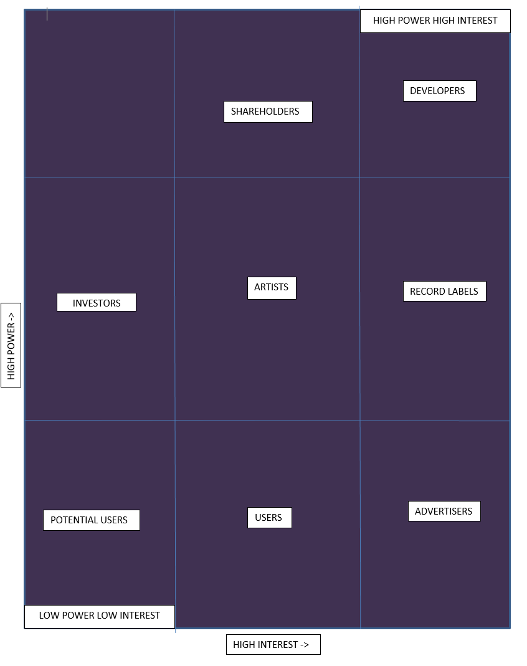

***\*spiro, the above is an image that you can just copy and paste, and below is the original form if you need to change anything.***

INVESTORS

SHAREHOLDERS

USERS

POTENTIAL USERS

ADVERTISERS

RECORD LABELS

ARTISTS

DEVELOPERS

HIGH INTEREST ->

HIGH POWER ->

LOW POWER LOW INTEREST

HIGH POWER HIGH INTEREST